# Setup Documentation for Developer

**Setup Documentation**   
We are going to use 2 different set up's one for back-end services app and another for front-end Angular app.   
**Back-end Services (Spring Boot) App set up:**

1. Java 8 (version "1.8.0-121")
2. Eclipse (Version: Neon.3 Release)
3. Get below plugins from Eclipse Market place (Note: get latest versions)
   * Buildship Gradle Integration
   * EclEmma Java Code Coverage
   * Spring Tools ( Spring IDE and Spring Tool Suite)
   * MoreUnit

**Front-end Angular (Angular 5) App set up:**

1. Install Visual Studio Code (<https://code.visualstudio.com/>) Note: Extensions will install automatically.
2. Install Node.js 9.2.0 (<https://nodejs.org/en/>)
3. To install Angular CLI(5.5.1) please use below steps
   * Go to terminal/command prompt window and type npm install -g @angular/cli
   * If you get below error

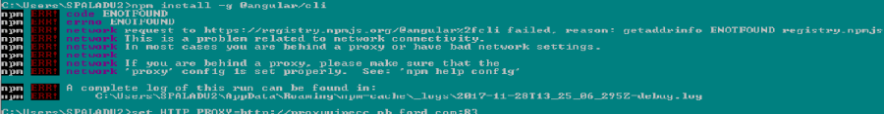

* + Use below commands in cmd line and rerun install command
    - set HTTPS_PROXY=<http://proxyvipecc.nb.ford.com:83>
    - set HTTP_PROXY=<http://proxyvipecc.nb.ford.com:83>
  + Once npm is installed sucessfully create a new angular project: ng new uvis-test
  + Go to project directory: cd uvis-test  and run this command: ng serve (this brings up run time environment)
  + Go to Chrome browser and access this link <http://localhost:4200/>
  + To open Angular application in VS Code, open another terminal/command prompt window and go to project directory and type: code .

**GIT repository can be accessed via client**

1. GIT Client (Git 2.14.1 is recommended***,*** [**click and download this version using this**Git Client link](https://github.com/git-for-windows/git/releases/download/v2.14.1.windows.1/Git-2.14.1-64-bit.exe)**.)**

Note: We still need to get GIT repository access.  
**PCF Sandbox Instance (For practice purpose only)**  
Note: Please talk to Team Leader before you submit request center ticket. If one of your team members has access to sandbox (requested on his cdsid) ask Org manager to assign space developer role to that instance you can skip step 1 and 2.

1. Submit request center ticket for PCF 45 day trial ([**Click here for Instructions on How to Complete Request for 45 Day Trial**](https://communities.spt.ford.com/sites/PCF/SharedDocuments/PCF30DayRequestInstructions.docx)).

## Have a PCF environment – see your email confirmation after requesting your 45 Day Trial org

## Install the Cloud Foundry CLI – Click the open button, then double-click on the Cf_intaller.exe file -  [{+}](https://cli.run.pivotal.io/stable?release=windows64&source=pcf1.7)<https://cli.run.pivotal.io/stable?release=windows64&source=pcf1.7+>

## Jeanne our Org Manager has to create space and assign space developer role for developers.

## Go to terminal/ command run below commands:

* + 1. set HTTPS_PROXY=<http://proxyvipecc.nb.ford.com:83>
    2. set HTTP_PROXY=<http://proxyvipecc.nb.ford.com:83>
    3. cf login –sso –a api.sys-pcf01.cf.ford.com

## Note: If you are working from home please don't use proxy commands above instead use no proxy command: set no_proxy="localhost, 127.0.0.1, .ford.com, 19.0.0.0/8, 10.0.0.0/8, 172.16.0.0/12, 192.168.0.0/16"

## Terminal window will prompt for passcode like below screen C:\de146b0716a4d9770889e59c0338ddc7

## Using chrome browser access this url <https://login.sys-pcf01.cf.ford.com/passcode>, click on Ford IT's Single Sign On with ADFS option and get temporary authentication code paste code in terminal window.

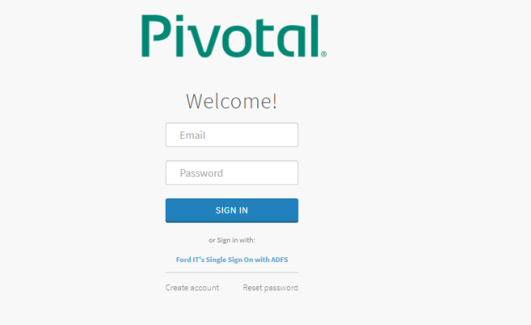  
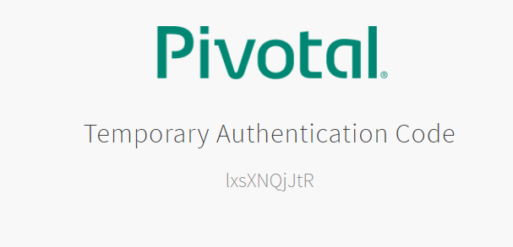

## Get the sample projects from <https://github.com/18F/cf-hello-worlds> click on Green clone or download button and download zip file or you can create your own project.

## Navigate to project in terminal window and perform push to PCF sandbox environment : cf push appName

## Note: If you don't specify how many instances and memory information while doing push it will use default value 1 instance and 1GB memory.

## Using chrome browser access this url <https://login.sys-pcf01.cf.ford.com/login> will take you to below screen and click on white space will take you to apps manager

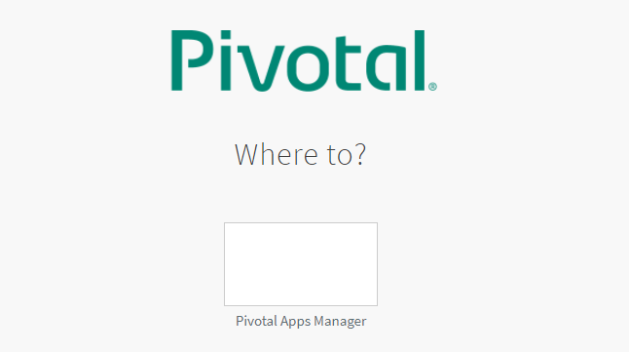

## From left side navigation click on space name, in app section see whether application you deployed is running or not by accessing route url and also click on app name to see logs tab.

## ****Steps for Org Manager to create space in sandbox PCF and to assign roles to developers****

## Login into pre prod PCF instance via terminal/ command prompt

## cf login --sso -a api.sys-pcf01.cf.ford.com

## Access below url in chrome to get passcode and paste it in terminal window when ever prompted.

## <https://login.sys-pcf01.cf.ford.com/login>

## If mutiple orgs are created before then select the org sequence number in which you want to create space

## Org>sequence number

## Note: you can select org only if there are multiple org's.

## Create new space in org using command: cf create-space newspacename

## Assign roles to developers using command: cf set-space-role spaladu2@ford.com orgname newspacename SpaceDeveloper

## Note: To check who all users have access to the space use command: cf space-users orgname spacename

## Note: Org Manager can assign roles to mutiple users through App Manager too. In order to use this feature manger has to assign role to at least one user from CF CLI.

## ****Postman****

## Get the Postman to test API request and responses from below location

## <https://it2.spt.ford.com/sites/FCAutomatedTesting/Pages/Postman.aspx>